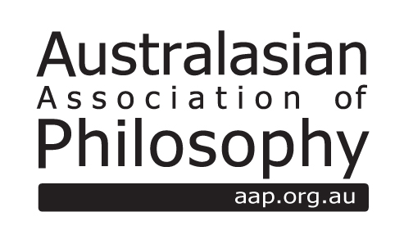
AAP Postgraduate Conference Fund
2017 Application form
https://aap.org.au/conference-fund/

The AAP Postgraduate Conference Fund is created to support conferences, workshops, seminars, and other similar events on philosophical topics that are organised by postgraduate members of the Association. Such events can be directed at an audience of philosophers or at a wider public.

Applications to the AAP Postgraduate Conference must complete this nomination form, which is in three (3) sections:
1. Applicant and Project Details – information about the applicant, proposed event and draft budget
2. Faculty Sponsor – nomination of a Faculty sponsor and Event evaluation report*
3. Department (or equivalent) declaration – signed declaration of support from your Department (or equivalent).
*Nomination of a Faculty Sponsor. (A Faculty sponsor will often be the applicant’s supervisor, but need not be). Faculty sponsors are asked to provide a brief confidential evaluation of the proposed conference or event, which should be emailed separately to the application.
Applications will be evaluated and ranked by an Evaluation Panel on their philosophical merits, and funding from the Fund will be distributed in line with these rankings. The total fund in AUD2000 is 2017 - no successful proposal will be allocated more than 50% of the Fund. An announcement of successful applications will be made in late November 2017. Any funded conference or event should occur within 12 months of the Panel's decision. Applicants whose proposals are successful will need to agree to any conditions the Association places on funding, and will also need to submit a brief report on the conference at the conclusion of their event.
More information, including conditions on accepted funding>> AAP Postgraduate Conference Fund Policy (available to AAP members only)
Eligibility
Any applicant to the fund must be a research postgraduate (Postgraduate or Masters by Research) and an ordinary member of the Association in good standing at the time of application.
Email applications to admin@aap.org.au
Email Faculty Sponsor evaluations to EO@aap.org.au
Applications and Evaluations must be received by Friday 13th October 2017.
SECTION 1 APPLICANT AND PROPOSED EVENT
1.1 Applicant details
Name:
University:
Email Address:

1.2 Title of Proposed Conference, workshop, seminar or similar event

1.3 Proposed date and location

1.4 Names of any invited and/or confirmed speakers

1.5 Description of the proposed theme and expected activities at the conference (up to 1 page)

1.6 Draft budget
Please include with your application a draft budget including indicative quotations for any significant expenses (such as travel, accommodation, or catering). The budget should note any funds to be provided from other sources, and whether there will be any fee for registration. The budget should also indicate how much is sought from the Fund.

SECTION 2 FACULTY SPONSOR
2.1 Faculty sponsor details
Name:
University:
Email Address:

2.2 Event evaluation
Faculty sponsors should provide a brief (circa 1 page) confidential evaluation of the proposed conference or event. This evaluation should address the philosophical significance and importance of the proposed conference, the feasibility of the proposed conference, and the suitability of the applicant as an organiser. The evaluation should also include an undertaking that the sponsor will provide guidance and advice to the organizer. Evaluations should be emailed separately to: EO@aap.org,au

SECTION 3 DEPARTMENT DECLARATION OF SUPPORT
3.1 Pro forma declaration signed by the Head of Department (or equivalent)

I declare that the (insert applicant’s Department or equivalent) is supportive of the application to the AAP Postgraduate Conference Fund and will contribute the resources outlined in the application if the application is successful.

_______________________________________________________________________________________
Signature

Name Date

