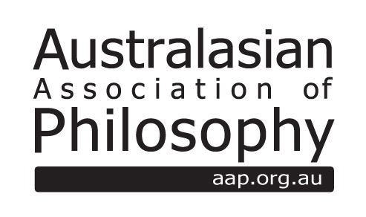

The AAP Annette Baier Prize
Nomination Form
http://aap.org.au/prizes/annettebaierprize

Name of Nominee:

Position:

Email Address:

Publication citation details:

Publication URL:

If this is a nomination on behalf of someone else:

Name of nominator:

Position:

Email Address:

Please include a PDF copy of the nominated piece in its published form with this nomination form.

Entries/nominations for pieces published in 2016 should be in electronic copy and must be received by the Executive Officer no later than 28th February 2017.

About the Prize

The Australasian Association of Philosophy (AAP) offers each year a monetary prize for an outstanding philosophical paper or book chapter published by an Australasian woman during the previous calendar year.

Eligibility
Papers must be nominated to be considered for the prize. Nominations may be made by the author or by someone else. Entries must appear in print (or in final form if the publication is online only) in the year previous to the prize award. The prize is open to published papers or book chapters (i.e. chapters in edited anthologies) in any area of philosophy.
The prize is open to female professional philosophers who are actively engaged in an Australasian higher education and/or research institution.

Criteria of Evaluation:
Entries should be received in electronic copy and include:
• A completed nomination form
• A PDF copy of the nominated piece in its published form
• Full citation details

